POWERPOINT COURSE SYLLABUS (15 Days)
Module 1: Introduction to PowerPoint
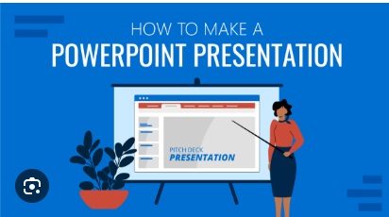
- What is Microsoft PowerPoint?
- PowerPoint Interface Overview
- Uses of PowerPoint in Daily Life & Business
- Opening, Saving, and Closing Presentations

Module 2: Creating Basic Presentations
- Creating a New Presentation
- Using Templates and Themes
- Adding and Managing Slides
- Slide Layouts

Module 3: Working with Text
- Adding Text Boxes
- Formatting Text (Font, Size, Color, Bold, Italic, Underline)
- Bullets and Numbering
- WordArt and SmartArt

Module 4: Working with Multimedia
- Inserting Images and ClipArt
- Inserting Audio and Video
- Using Screenshot and Screen Recording

Module 5: Charts, Graphs & Tables
- Inserting Tables
- Creating and Formatting Charts
- Using Graphs to Represent Data
- Excel Integration

Module 6: Design and Transitions
- Slide Design and Backgrounds
- Using Themes and Variants
- Slide Transitions
- Slide Master and Layout Customization

Module 7: Animations
- Object Animations (Entrance, Emphasis, Exit, Motion Paths)
- Animation Pane and Timing
- Custom Animation Effects

Module 8: Slide Show Presentation
- Starting a Slide Show
- Navigating Slides during a Presentation
- Rehearse Timings and Narration
- Presenter View

Module 9: Exporting and Sharing
- Printing Slides and Handouts
- Saving as PDF or Video
- Sharing via Email or OneDrive

Module 10: Mini Projects / Practice
- Create a Resume in PowerPoint
- Business Presentation/ Animated Photo Album
- Educational Topic Presentation

